GCH Board Meeting Minutes
April 16, 2024
Meeting held at the home of Claire Burnett

Call to order at 12:00 PM by Claire Burnett

Present: Claire Burnett, Susie Barney, Mally Cox-Chapman, Briann Greenfield, Mary Ann Haar, Marcia Hall, Carrie Hammond, Kitty Hickcox, Nora Howard, Marian Kellner, Kathy Kraczkowsky, Mem Morrissey, Katie Nixon, Susan Prentice, Brie Quinby, Sally Richter, Katy Sargent, Mara Sfara, Donna Stout, Margaret Szerejko
Guests: new members Jill Chase and Diane Mack

A motion to accept the March 19, 2024 Board Meeting minutes was made, seconded and approved.

President’s Remarks - Claire Burnett
- Annual Committee Reports are due at the GCH Annual Meeting on May 7th. Please bring two printed copies, one for the president and one for the historian. Please send electronic copies to Claire for the website and Nora Howard for the archives.
- Committee and Officer Binders should be brought to the May Board meeting to pass along to the incoming chairs. If you have electronic files to share on a flash drive that is also very helpful.
- Annual Meeting volunteer reminder emails have gone out from the Annual Meeting Volunteer Chairs. Let Claire or Kristen know of you have any questions. Please make sure to confirm your attendance and receipt of the email with the Chairs.
- Trumpet Vine articles are due this Friday, April 19th.
- The May Board meeting will include both the current and incoming board members.
- A few volunteers are needed to help take down the flower arrangements at the end of the GCA Annual meeting, Sunday April 28, between 4PM and 6PM. See Claire or Mary Ann.

Treasurer’s Report - Briann Greenfield
As of April 14,2024
Carry Over | $6,358.71
Carry Over Fund 5301 | $1,175.50
13 Month Featured CD 8877 | $5,5183.21
Main | $14,505.66
Main Checking Account 0738 | $14,505.66
7 Month Featured CD 8880 | $0.00
Perennial | $20,668.92
Perennial Fund 7034 | $2,009.37
13 Month Featured CD 8990 | $18,659.55
Rainy Day Fund 9004 | $4,518.92
Community | $73,328.93
Community Fund 8539 | $62,962.52
13 Month Featured CD 8864 | $10,366.41
Education Fund 6342 | $10,398.08
Total | $129,779.22

- The Main Checking Account reflects partial FY 25 dues deposit.
- Annual GCH dues are due April 15. It is anticipated that a significant number will be late.
- Reminder: we have a new dedicated treasurer email. All check requests can now be emailed to treasurer@gchartford.org.

Committee Reports:

Scholarship - Sally Richter
Our 2023/2024 GCH scholarship recipient, Hartford Promise Scholar Sabrina Green, will be entering her senior year at RIT in the fall. She has sent a letter to the GCH thanking us for our support and outlining her ongoing impressive course of studies in environmental science, which aligns with the GCH’s mission.
A motion was proposed to accept the Scholarship Committee’s recommendation to, for the second year, award $1000.00 to Sabrina Green for her 2024/2025 senior year. The motion was seconded and approved by the board.

The supportive relationship of the GCH with Hartford Promise, the organization which has been the source of our scholarship recipients, was lauded. It was suggested that we try to submit an article about this to the GCA Bulletin.

Flower Design - Mary Ann Haar
We will be sponsoring a trip to the CT Flower Collective, 5 Cross St, Meriden on Friday May 31, for up to 25 people. We will carpool and meet in Meriden to visit the Collective from 10:15 - 11:30 AM , followed by lunch at Iliano’s Restaurant. An announcement will be placed in the next Trumpet Vine.

Visiting Gardens - Brie Quinby
- Trade Secrets CT is coming up May 18-19. If you are interested in any of the tours, go to the website tradesecretsct.com .
- On Thursday, June 6, we are sponsoring a tour of the Rose Garden at Walnut Hill Park at 10 AM, followed by lunch. At 1 PM, there will be a guided tour of an exhibit ‘Contemporary Art by Native Americans’ at the New Britain Museum of American Art. Details to follow in the next Trumpet Vine.
- On Saturday June 15, Brie Quinby is hosting a Garden Conservancy Tour at her home and garden. She will need help checking visitors in on that day, so if anyone is interested in volunteering to help out, it would be most appreciated. See Brie for details.

Garden History and Design - Nora Howard
Our committee’s documentation of the Peelle’s garden for the Smithsonian archives is almost completed. A detailed notebook has been compiled.

Civic Improvement - Kathy Kraczkowsky
We are ready to swing into action with the planting of The Park Street Library courtyard gardens.
For the current budget planning: In addition to the beds, we will be planting “benches” (raised beds on wheels) for the children.. We have decided not to use an irrigation system. We have compiled a list of plants. We have a curriculum and books on gardening for the children. We will be spending some our currently budgeted money in preparation for a planting day on May 22.
For future budget, we are considering assigning a QR code system to the various plants/shrubs. We are considering window box planters. This will be in the future.

New Business
Proposed GCH Budget is attached.
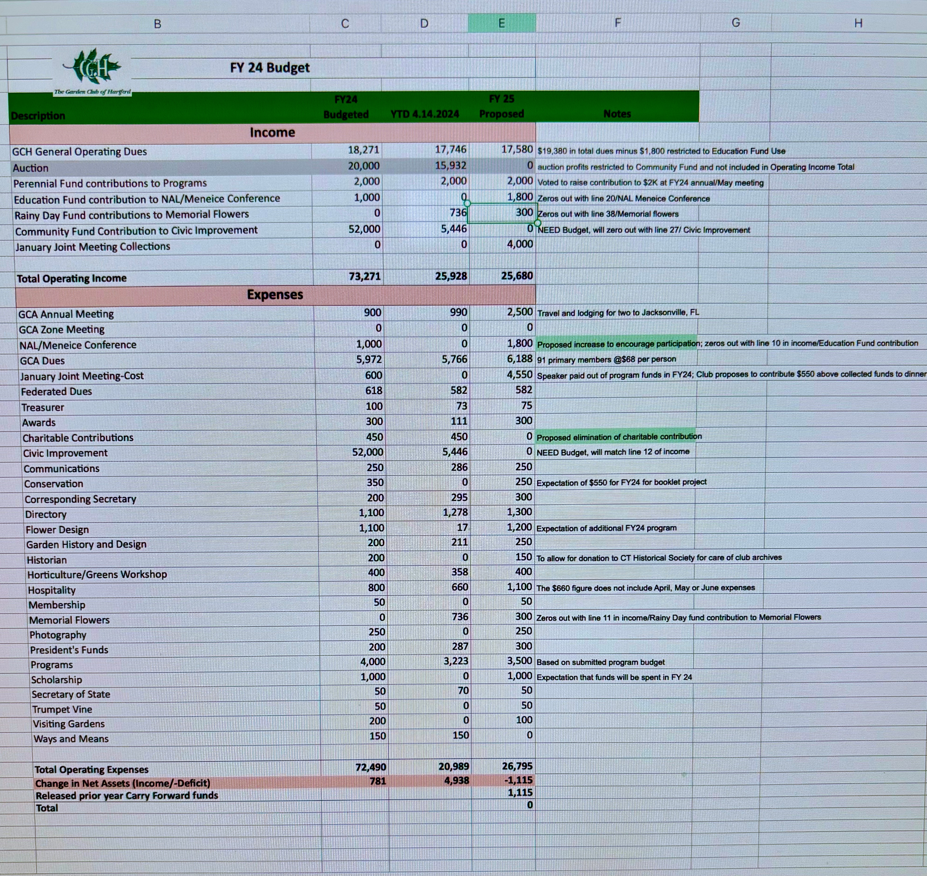
Budget discussion:

- The proposed operating budget anticipates a deficit of $1,115, which will be supported by prior year Carry Over funds. Cost are rising and our budget reflects these realities.
- General operating dues are based on 53 Active Members, 19 Associate Members, 23 Affiliate Members, and 2 New Members. $25 of each Active and Associate Member’s dues are restricted for the Education Fund and used toward NAL/Meneice Conference attendance. This portion of club dues is predicted to total $1,800 in FY25.
- We propose to increase the allowed funds for member reimbursement for attendance at the NAL or Meneice Conference to $1,800 to make this educational opportunity more accessible. Since the pandemic, GCA is only holding one of the two conferences in person each year (the other is held virtually). Therefore the allotted annual reimbursement fund would be designated for 2 members to attend the in-person conference being held that year. After discussion, a motion was made to increase the educational reimbursement for the in-person conferences to $1800 per person, per year, for a total limit of $3600 per year. The motion was seconded and approved by the Board
- With costs rising we propose to eliminate charitable contributions to other organizations. $150 remains budgeted to the Historian to provide a contribution to the Connecticut Museum of Culture and History (formerly, the Connecticut Historical Society), which maintains GCH’s archives. A motion was made to limit our charitable contributions to include only the CT Museum of Culture and History ($150.00 paid by the Historian) and eliminate all other charitable contributions for the coming fiscal year..The motion was seconded and approved
- The Civic Improvement budget has not been added yet. There is $73K in the Community Fund for use.
- We are rethinking how we budget for the Joint Meeting.

Following the discussion, a motion was made to accept the FY25 GCH budget as proposed. The motion was seconded and approved.

Other Business:

By- Laws revision:
Proposed changes include:

ARTICLE III. MEMBERSHIP:
Section 3.01
(b) iii a:Changing the age eligibility for Associate Membership from 65 to 70 years.
(c) ii b:Defining more clearly the requirements for Affiliate Membership
(f): Adding the statement “An active member may request a LOA if temporarily unable unable to fulfill duties as a member but wishes to remain part of the club. LOA must be requested in writing to the President.”
ARTICLE IV. ELECTION OF ACTIVE MEMBERS:
Section 4.01 -For each candidate for membership, the proposer shall obtain an application. The application and 2 seconding letters, must be completed and in the hands of the Membership Chair in March, specific date announced yearly.
ARTICLE V .OFFICERS:
Section 5.01: Changed to “The Officers of the Corporation are the President, Vice President, Corresponding Secretary, Recording Secretary and Treasurer. They shall be elected at the annual meeting.”
Section 5.02: Changed to” Vacancies in any office other than that of the President shall be filled by vote of the Board of Directors.”
ARTICLE VI.MANAGEMENT:
Section 6.01: The Executive Committee shall consist of the officers of the Corporation as specified in Article V, Section 5.01, plus a Member-at-Large, who may or may not be a past president…A simple majority of the Executive Committee shall constitute a quorum.
Section 6.02: Changed to “The Board of Directors shall consist of the Executive Committee and the chairs of all committees. The Board of Directors shall meet at the call of the President and shall have general supervision over the affairs of the Corporation, fill vacancies and elect new members. Seven members of the Board of Directors shall constitute a quorum.”
Section 6.05 - Changed to “There shall be a Committee for the Nomination of Officers consisting of three members appointed each year by the Chair of Nomination. The Chair shall present the report of the Committee at the Annual Meeting.”
ARTICLE VII. DUES
Section 7.01 - Changed to “Dues and fees will be paid annually, the amount to be determined by the Board of Directors and approved by the Corporation.”
ARTICLE IX. INDEMNIFICATION:
Changed to “The Corporation [or use organization corporate name] shall indemnify any Director or Officer against any threatened, pending, or completed action, suit, or proceeding relating to or arising out of the performance of his or her duties in the manner and to the fullest extent provided by the law.”

After discussion, a motion was made to accept the revised GCH By -Laws as proposed. The motion was seconded and approved.

The business meeting was adjourned at 1:00 PM

The new GCH members, Jill Chase and Diane Mack were formally welcomed by the Board to the club. Committee Chairs gave brief descriptions of their committees’s purpose and activities, after which a lovely luncheon was enjoyed by all.

Respectfully submitted,
Margaret Szerejko
Recording Secretary

